**Railroad Solution Design**

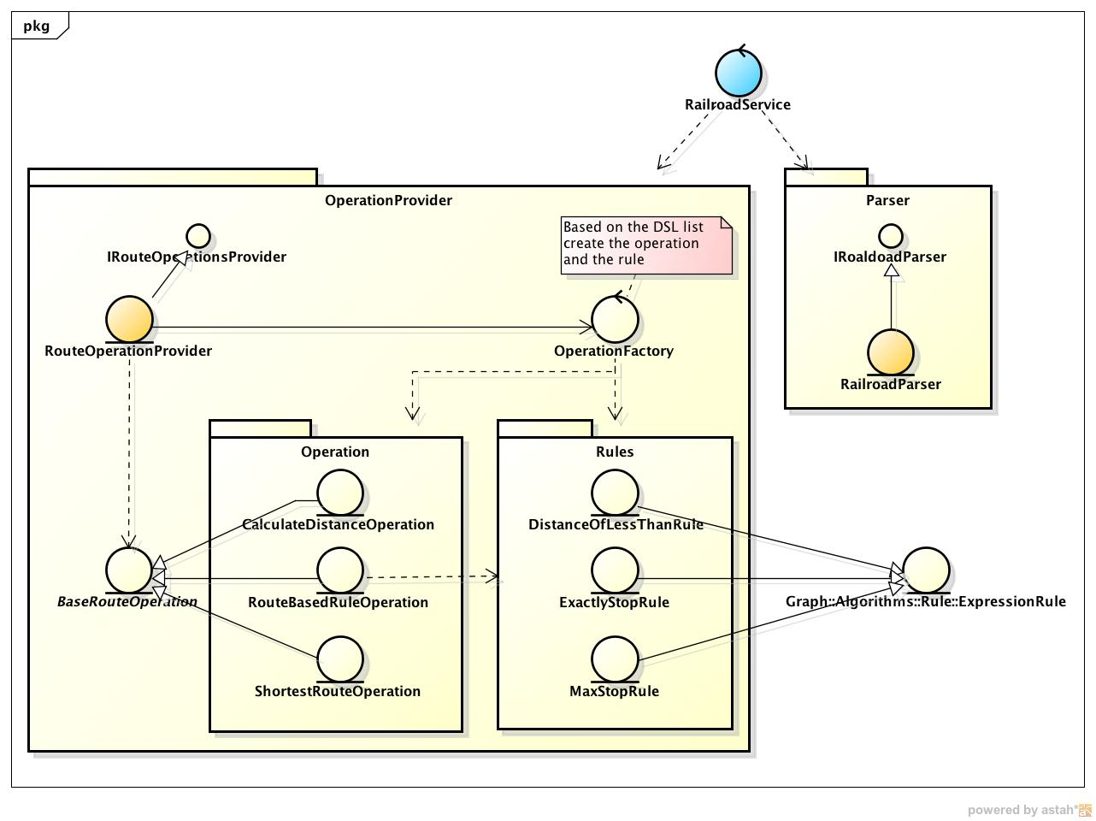

The main goals of this solution are:

- Create a design that separate all concerns in different components with clear responsibilities

- Keep the domain as separated as possible from the algorithms, calculation, etc...

- Provide extensibility in the context of new requirements/

Here we can notice the interaction of more important component

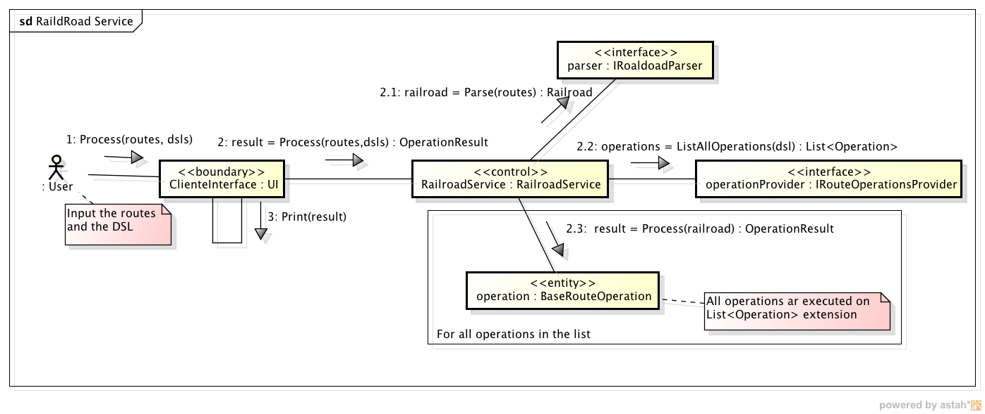

The service is the entry point for all runtime objects so it will ask the parser to translate the text related to the routes (ABD, ABC, ...) to a domain object RailRoad, the service than will evaluate the operations that should be perform by the dsl (ex: "calculate the distance, ...") and the operations will be executed. When a operation is executed it can build a graph object from the raildRoad and apply algorithms with specify rules to get the result.

The domain model is very simple and separated from everything else:

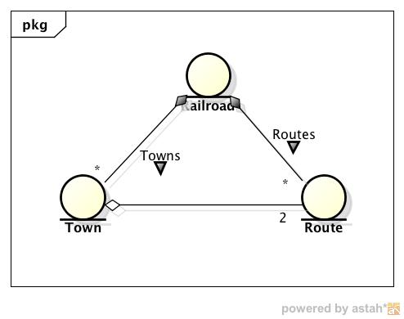

The Graph framework provides all the logic necessary to perform algorithms such as walk, etc...

